**In-Game Element Modification Techniques**

How other games do it

Big Pharma

In big pharma, there are four types of machines that perform element modification: Basic, Advanced, Auxiliary and Makers. I will briefly go over each of these types of machine and how they affect gameplay.

Basic machines take an input and modify concentration of that input. There are some that increase/decrease the concentration by 1 (‘Evaporators’ and ‘Dissolvers’), some that increase/decrease it by 3 (‘Agglomerators’ and ‘Ionisers’) and others that double/halve the concentration of an input (‘Autoclaves’ and ‘Cryogenic Condensers’). These are all relatively simple mechanics that act in a single property of an input, concentration.

It is worth noting that different machines have different ‘Process Costs’ and different ‘Process Time’ (Game ticks to complete the modification) so in the case of Big Pharma it is slightly more efficient cost-wise to have 3 Evaporators instead of 1 Agglomerator, but this would take up more space on the factory floor.

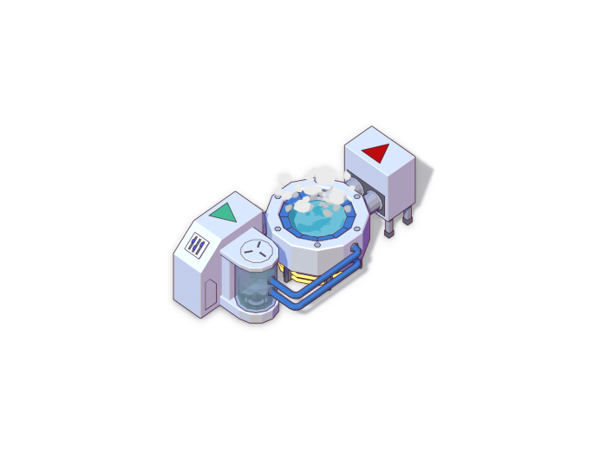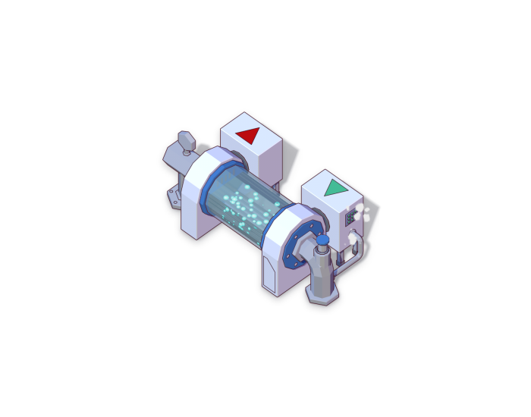

Figure Dissolver Figure Evaporator

Advanced Machines still affect concentration but usually in more drastic ways than basic machines. The first advanced machine, the ‘Ultraviolet Curer’ sets an inputs concentration level to 1. There is the ‘Sequencer’ which lets you select which concentration value you want the input to go to, from a set list of values (2, 10 and 18 in Big Pharma). The ‘Chromatograph’ takes an input and based on its current concentration level, either reduces or increases the concentration level by 10. Lastly there is the ‘Hadron Collider’ which is particularly strange. It sets the concentration of the input to all values possible. This has the effect of enabling all the effects and side-effects of the drug simultaneously, regardless of their concentration requirement.

In general, advanced machines cost a lot more and take a lot longer to operate than basic machines.

Auxiliary machines are different to the other machines covered since their purpose is not to affect concentration directly and therefore will require a bit more explanation compared to the previous machines.

First there is the ‘Analyser’ which takes an input, finds out which concentration level the effects and side effects of the ingredient are most potent (called the maximum strength concentration of a drug trait) and then destroys the input. The analyser has a success rate based on how often the input is given to the analyser. The more inputs fed to it over a set amount of time, the higher the success rate of finding the maximum strength concentration

of drug traits.

There is the ‘Multimixer’ which combines two ingredients traits together. This can be useful to gain positive effects for the drug being produces or to gain catalysts for that drug. The diagram below shows exactly how it works:

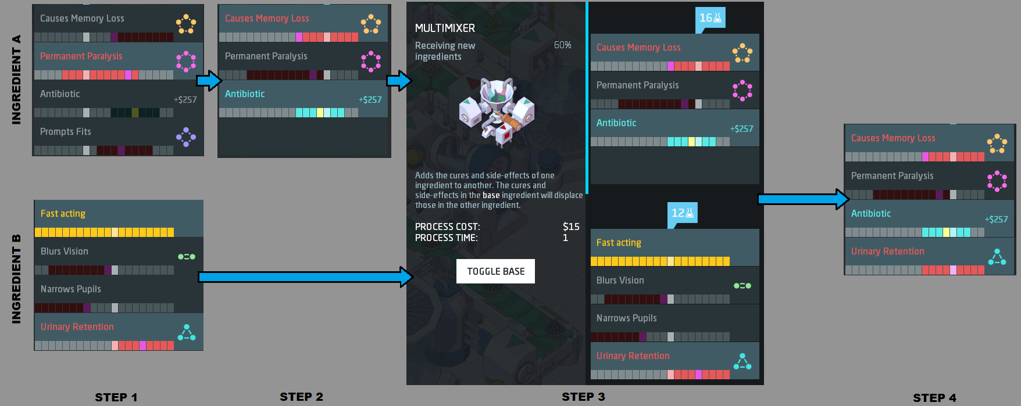

There is a ‘Shaker’ which switches the order of the drug traits, useful in combination with a ‘Multimixer’ to pass a trait on to a base ingredient.

There are a few auxiliary machines but I won’t go in to detail on them all since that isn’t the point of this research.

The final type of machine is a ‘Maker’ machine. These are used to package the drug up in a form that can be used by the consumer.

Firstly, there is the Pill Printer, with a process of time of 2 and taking up a relatively small amount of space compared to other maker machines, it is a good choice early on.

There is the ‘Creamer’ which has the benefits of reducing side effects by 50-75% and having a process time of 1, however it is expensive to run.

There is a ‘Sachet Fabricator’ which packages your drug in a sachet, it is nearly the same as the pill printer except for the fact that it’s slightly larger but adds more value to the finished product.

Finally, there is the ‘Syringe Injector’ which packages drugs in to a syringe form, increasing strength of the drug and value. It is the creamers counterpart.

As you can see, Big Pharma has a lot of detail in the machines used to modify drugs as this is the core mechanic the game relies on, so they fleshed it out a lot. They game also has research built in to it which lets your upgrade the machines over time, reducing process costs of the machines and providing other benefits.

Infinifactory